# Subject: Research Summary: Improving Client Meeting Prep for Investment Banking Teams

# Hi team,

# As part of our ongoing effort to rethink and improve how we support senior bankers in client meetings, I’ve conducted in-depth research on the end-to-end workflow of investment banking meeting preparation, using ServiceNow as a representative client.

# I’m sharing a comprehensive briefing that captures how top-tier banks (e.g., Goldman Sachs, Morgan Stanley) structure their client prep—from data gathering and internal coordination to GenAI-native tools and post-meeting follow-up. The research is designed to ground our thinking in real-world workflows while identifying opportunities to modernize and differentiate our experience.

# What this research includes:

# A full end-to-end workflow of how investment bankers prepare for a meeting

# The different types of client meetings (e.g., M&A pitch, strategic review, IPO readiness) and what success looks like in each

# The roles and responsibilities of Analysts, Associates, VPs, and MDs

# A summary of tools and data sources commonly used in prep (e.g., CapIQ, FactSet, CRM)

# Best practices from bulge bracket banks that lead to more impactful client conversations

# Common pain points in the current prep process, and how GenAI or workflow tools can solve them

# A breakdown of success metrics and post-meeting actions used to measure meeting effectiveness

# This research can serve as a foundational reference as we reimagine the banker experience. Happy to walk through this in more detail or discuss how it can inform the next phase of our design.

# Best,

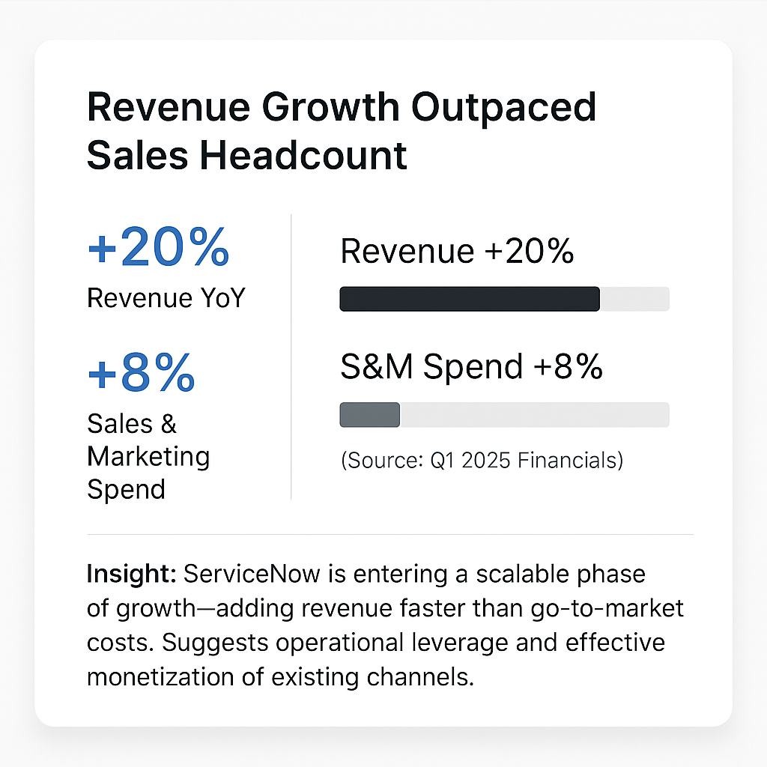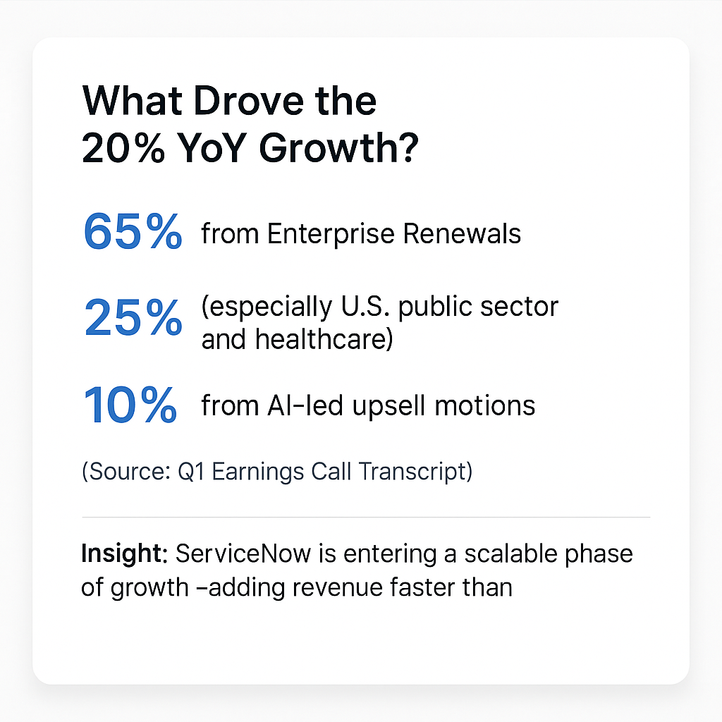

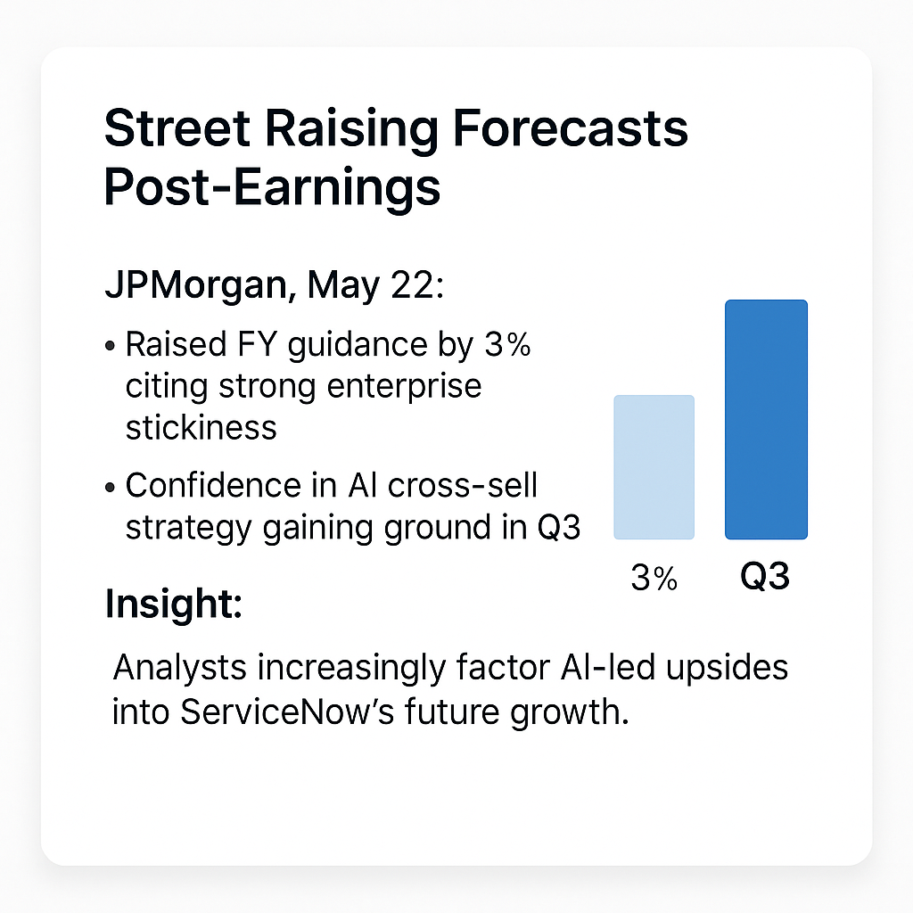

# 

# 

# 

Below is a comprehensive overview of how bankers prepare for a client meeting with ServiceNow, covering each stage of the process, types of meetings, tools and data, team roles, best practices, pain points, and how success is measured.

## 1. End-to-End Preparation Workflow

Investment bankers approach client meeting prep as a multi-step project, starting from initial scheduling through final follow-ups. Each step is carefully managed to maximize the meeting’s impact:

1. Meeting Scheduling & Agenda Setting: The process begins with the Managing Director (MD) or coverage banker (often the primary relationship manager) reaching out to ServiceNow’s executives (e.g. CFO or CEO) to arrange the meeting. This involves coordinating calendars (often via executive assistants) and agreeing on the meeting’s purpose and attendees. An agenda or at least a clear meeting objective is set in advance – for example, a discussion on potential AI-related acquisitions or a review of capital raising options. The MD leverages the established relationship to ensure the meeting is positioned as value-add for the client. At this stage, the team internally discusses what ServiceNow likely wants to hear and what the bank aims to achieve (e.g. showcasing a new idea or progressing a deal opportunity).
2. Internal Data Gathering: Once the meeting is confirmed, the team gathers internal data and past records related to ServiceNow. Analysts pull up the bank’s CRM records of prior interactions – e.g. notes from previous meetings, any mandates or deals the bank has done for ServiceNow, and the status of past pitches or proposals. They review internal research reports from the bank’s equity research department on ServiceNow and its competitors, as well as any relevant industry reports the bank’s knowledge portal might have. Internal financial models or valuations prepared in the past (for example, a model from a prior pitch on a potential ServiceNow acquisition) are retrieved and updated. The team also checks if colleagues in other product groups (M&A, Equity Capital Markets, Debt Capital Markets, etc.) have insights – for instance, if the DCM team has evaluated ServiceNow’s debt capacity before. Internal coordination is key even at this stage: bankers work together across departments to share information so that the upcoming meeting’s content aligns with both the client’s known preferences and the bank’s strategies . Often, critical knowledge about the client is “locked away” in individuals’ heads or scattered in emails and spreadsheets, so the team consolidates these insights into a common view . This ensures the bankers are fully aware of ServiceNow’s history with the firm and any sensitive issues or opportunities previously identified.
3. External Data Gathering: In parallel, the team gathers external data to update their understanding of ServiceNow’s current situation and the broader market. Analysts will download the latest financial information on ServiceNow – recent earnings, stock performance, valuation multiples – using tools like S&P Capital IQ and FactSet . These platforms provide detailed company financials, consensus forecasts, and peer benchmarks. The team checks Bloomberg for real-time market data and news on ServiceNow . For example, if ServiceNow’s share price moved significantly or if a competitor made a major move, the bankers need to know and be ready to discuss it. They scour news feeds (Factiva, Bloomberg News) and analyst reports for any developments in ServiceNow’s industry (enterprise software) – particularly around AI trends, since ServiceNow has been actively investing in AI capabilities. (Indeed, in 2025 ServiceNow announced plans to acquire an AI startup for $2.85 billion , so bankers would note such facts.) The team also researches comparable companies and recent deals: e.g. have other software companies made acquisitions of AI firms recently? what valuations and rationales were involved? If the meeting’s focus might touch on a capital raise, bankers pull data on recent tech company financings (debt issuances, convertible bonds, etc.) to gauge market conditions. External data sources like Dealogic or Refinitiv are used for M&A and capital markets deal league tables and precedents, while databases like PitchBook or Mergermarket might be searched for information on private companies or rumored targets. This comprehensive data gathering ensures the team is armed with up-to-date facts – both public information and third-party data – to support any advice or ideas they present.
4. Internal Coordination & Brainstorming: With raw information in hand, the deal team (analyst, associate, vice president, and MD) holds internal sessions to synthesize insights and plan the meeting approach. They discuss ServiceNow’s likely interests and pain points: for example, is ServiceNow looking for growth via acquisitions (and if so, in AI or other areas)? Are they concerned about their stock valuation or investor expectations? The team may hold a brainstorming meeting including product specialists. For instance, if the upcoming client meeting might delve into financing, they invite a debt capital markets banker to weigh in on feasible loan or bond options; if it’s about M&A, the sector M&A specialist or an experienced VP may join to refine deal ideas. During these internal prep meetings, roles for the client meeting are allocated – typically, the MD will lead the conversation, but senior team members decide which points each person might handle if needed (though juniors often remain silent unless called upon). The team aligns on key messages and recommendations. Scenario planning is a big part of this step: they anticipate the client’s questions and reactions. For example, “If ServiceNow’s CFO asks about the valuation of a specific AI startup we propose as an acquisition target, do we have a view on that ready?” or “If the CEO expresses concern about diluting shareholders with a capital raise, what alternatives can we suggest?” The team might prepare Q&A sheets or backup slides to address potential queries. Internally, they may even rehearse the meeting – senior bankers might role-play as the client to probe the team’s ideas. All of this coordination is to ensure a unified, well-prepared front when facing the client. As one industry resource notes, internal coordination means working across the team and firm to agree on deliverables and timelines in advance – no surprises internally or for the client.
5. Pitchbook and Materials Preparation: Using the insights gathered, the junior bankers (analyst and associate) compile the pitchbook or presentation materials. This is often a PowerPoint deck tailored to ServiceNow’s situation. The process is highly collaborative: typically the MD (and possibly a Director or VP) first outlines the presentation’s story and content flow . For example, they might decide: “Let’s start with a summary of ServiceNow’s strong position in the market, then highlight new opportunities in AI, segue into specific acquisition ideas with valuations, and conclude with how our bank can help execute these plans.” The VP or Associate creates a detailed outline or “wireframe,” and then the analyst crunches numbers and produces the exhibits . This can include valuation analyses (trading comps, precedent M&A transactions, DCF scenarios) and market stats. All data must be double-checked for accuracy and consistency (e.g. aligning figures with the latest stock price and financials). The pitchbook for ServiceNow would be heavily customized: it might contain an overview of relevant AI acquisition targets (with profiles of each target company), analysis of how such an acquisition could enhance ServiceNow’s product offerings, a valuation summary (perhaps a “football field” chart showing ServiceNow’s valuation range under different methods), and financing considerations for a purchase . If the meeting is about strategic planning, the deck might include broader industry trends (like enterprise software growth areas, competitive moves) and “thought pieces” on strategy. Throughout this phase, there are typically multiple iterations of the deck – senior bankers review drafts and send them back with edits. It’s not uncommon for numerous revisions to occur, sometimes resulting in dozens of version files (e.g. “Project_SNOW_v44.pptx” as a final file name) . Top banks have a high standard for presentation quality: every chart, page and footnote must be perfect, and formatting is refined obsessively to look seamless. (At bulge brackets, there may be a dedicated graphics team to polish slides, whereas at a mid-market firm the analysts themselves might spend late nights perfecting the visuals.) The end product is a pitchbook that not only presents analysis but also tells a coherent story aligning with ServiceNow’s goals. Supporting materials are also prepared: this could include an Excel model printout (e.g. a model of a proposed acquisition’s impact on ServiceNow’s earnings), an appendix of data (detailed comps, etc.), or even a brief “tear sheet” summary the client can take away. Importantly, the team will also prepare any leave-behind documents per compliance rules (removing any bank-internal confidential information if needed).  
     
    Example of a valuation summary slide that might appear in a pitchbook, illustrating ServiceNow’s value under different scenarios. Bankers prepare detailed analyses like this to inform discussions .
6. Pre-Meeting Final Checks & Scenario Planning: In the day or hours before the meeting, the team does a final scrub of everything. They update any data in the deck for last-minute changes (for instance, if ServiceNow’s stock moved sharply that morning or if a competitor announced an earnings surprise the night before). They print hard copies of the presentation (on high-quality paper or binders, especially at bulge brackets where presentation aesthetics are part of the polish ) and ensure they have access to electronic copies (sometimes bankers carry an iPad or have the deck on a USB drive as backup). The bankers convene a short prep session to go over the meeting game plan one more time: who will introduce what topic, and how to steer the conversation toward the bank’s key suggestions. “Client scenario planning” is essentially finalized now – the team re-visits their anticipated Q&A, and each member is briefed on how to handle tough questions. For example, the MD might say: “If the CFO asks about how we see macro conditions affecting tech valuations, I’ll address that using the market data slide. If they ask something highly detailed about a particular target’s financials, <Associate’s name>, be ready to chime in with the numbers from our appendix if I cue you.” The analyst and associate bring along backup data (either extra slides in an appendix or a separate report) for reference, so they can quickly retrieve details if the client drills down on something unexpected. Travel logistics are confirmed (if the meeting is at ServiceNow’s office in Santa Clara, the team travels there, or if at the bank’s office, the conference room is booked and set up). Everyone arrives early, professional and armed with knowledge, so that once in the meeting, they can focus on listening and engaging the client rather than fumbling for information. By the time they walk into the room, the bankers have effectively pre-lived the meeting in their minds and are ready for various outcomes.

## 2. Common Meeting Types with ServiceNow and Their Characteristics

Bankers typically engage with a corporate client like ServiceNow in a few main types of meetings, each with different objectives and content. Below are key categories of meetings and what each entails, including typical discussion points, materials, and measures of success:

### M&A Idea Generation Meetings

Purpose & Discussion: These are proactive strategy sessions where bankers present merger and acquisition ideas to ServiceNow’s leadership. The focus is on idea generation – identifying potential companies or assets ServiceNow could acquire (or occasionally, businesses it might divest). Bankers discuss the client’s growth strategy and how M&A could fit: e.g. “Where can ServiceNow expand next? Perhaps acquiring an AI workflow automation startup to bolster your platform.” They will talk through industry M&A trends (for instance, noting that tech M&A activity rebounded in 2024-2025 , and that peers like Salesforce, Oracle, etc., have been buying companies in AI or other strategic areas). The core discussion points include the rationale for each suggested target, estimated synergies or product benefits, and high-level financial implications (cost of acquisition, impact on earnings, etc.). Bankers also listen for the client’s M&A appetite – ServiceNow’s CFO might emphasize they are disciplined about deals , so ideas need to be realistic.

Materials Brought: A tailored pitchbook is usually prepared, containing an overview of each M&A idea. This typically has profiles of target companies (business overview, product fit, revenues, etc.), valuation estimates for each target, and perhaps a one-page financial impact analysis (what the acquisition might do to ServiceNow’s earnings or growth). For the top one or two ideas, bankers might include a simple pro forma model showing the deal’s effect (e.g. accretion/dilution to EPS or how it could be funded with cash vs. debt). Comparative data on precedent transactions is often included – e.g. “similar AI-focused acquisitions in the last year traded at 10x revenue; here’s how our target compares.” They’ll also include market backdrop slides: how ServiceNow’s stock valuation compares to targets or how much cash and debt capacity ServiceNow has for deals. All of this is often prefaced by an “industry landscape” summary to set context.

Successful Outcome: Success in an idea generation meeting is measured by engagement. A great outcome is when ServiceNow’s executives show interest in one or more of the proposed ideas – for example, the CFO might say, “Tell me more about how you envision integrating Target X” or “These two AI targets are intriguing; perhaps we should do deeper dives on them.” If the client asks the bank to follow up with more analysis on a specific target or even to initiate informal contact with a target, that’s a strong positive signal. In the long run, the ultimate success is if one of these ideas eventually leads to a mandate – i.e. ServiceNow formally hires the bank to execute an acquisition. But even short of that, a meeting is successful if it advances the dialogue: the client perceives the bankers as creative and knowledgeable advisors. An unsuccessful meeting, conversely, would be one where the client is lukewarm and there are no clear next steps. Bankers often log idea pitches in their pipeline; a “win” is if those ideas move forward (even if slowly). As one M&A guide notes, the initial discussion with a client is about identifying their goals and discussing potential targets or buyers – essentially what these idea meetings aim to do .

### Strategic Review / Planning Meetings

Purpose & Discussion: These meetings are broader, high-level discussions where bankers act as strategic advisors. Often scheduled annually or quarterly (or when major market changes occur), a strategic review covers the company’s overall objectives, challenges, and opportunities. With ServiceNow, bankers might review the company’s positioning in the market (enterprise cloud software) and discuss big-picture topics: “What’s the next wave of growth? How do rising interest rates or shifting IT budgets affect your strategy? What are competitors doing (like Salesforce entering certain spaces) and how should you respond?” Core discussion points include industry trends (e.g. adoption of AI in enterprise software, cloud spending outlook), competitive landscape, and potential strategic moves (this can span M&A, partnerships, new market entry, or even organizational/financial strategy like splitting off a division). Sometimes these meetings are held ahead of a board meeting or planning cycle, so bankers try to provide an outside perspective that management can weigh. It’s more of a two-way dialogue: bankers share insights and also listen as the client voices their strategic priorities or concerns.

Materials Brought: The materials here may be less deal-specific and more about context and options. Bankers often bring an “industry update” deck. For ServiceNow, this might include: current market metrics (growth rates in relevant software segments, valuation multiples of peers), a competitor moves summary (who’s acquiring whom, who is investing in what technology), and possibly case studies of relevant strategic moves (e.g. how another tech company successfully pivoted to AI, or how a peer optimized its capital structure to fund growth). There might also be a SWOT analysis or positioning matrix showing ServiceNow’s strengths vs. competitors. If ServiceNow has expressed specific interests previously (say, exploring expansion in a certain geographic region or product area), the deck will include analysis of that (market sizing, potential entry strategies). While this is not a formal “pitch” for one transaction, the bankers will usually embed ideas in the conversation – for example, highlighting that “several smaller competitors are struggling; perhaps there’s an opportunity to acquire talent or tech cheaply” or “your balance sheet could support more leverage if you wanted to do a large buyback or acquisition.” The presentation often ends with a few “strategic options” slides enumerating possible paths (organic growth, M&A, partnerships, etc.), effectively planting seeds for future mandates .

Successful Outcome: In a strategic review, success is a bit intangible but very important for relationship-building. A successful meeting is one where the client gains valuable perspective – if ServiceNow’s executives say something like, “That’s a useful way to look at the market; we hadn’t seen that analysis” or “Your suggestion about our AI product strategy is interesting,” it means the bankers have delivered insight beyond what the company already knows. Often the best outcome is when the client asks the bank to continue the conversation, maybe to present to the broader management team or board. For example, ServiceNow might invite the bankers to a follow-up session with the CEO or to a board strategy offsite, indicating trust in their advice. Long-term, success is measured by being kept “in the loop” on the client’s strategic considerations. If, down the line, ServiceNow decides to explore a major strategic move (sell a division, make a big acquisition, etc.), they are likely to call in those bankers as advisors. In the short term, even without a transaction, success can be the client disclosing more of their internal thinking (which means they see the bankers as confidants) or simply scheduling the next strategic check-in. Essentially, the meeting is a success if it reinforces the bank’s position as a trusted advisor with relevant ideas, rather than just a vendor of financial services.

### IPO Readiness / Equity Financing Check-ins

Purpose & Discussion: Although ServiceNow is already a public company (NYSE: NOW), bankers might hold similar meetings for other high-growth clients or in cases where ServiceNow could consider equity moves (e.g. a secondary offering, or spin-off of a division via IPO). In general, an “IPO readiness” meeting (for a private company) covers what a company needs to prepare for a public offering. If we imagine ServiceNow were private or a division of it was to be spun out, bankers would discuss topics like financial reporting upgrades, governance, market timing, and valuation in an IPO context. For ServiceNow specifically, an analogous meeting could be an equity market check-in – discussing investor perceptions, the company’s stock performance, or the feasibility of raising equity capital for expansion. Key discussion points include the current IPO market conditions (e.g. “Are tech IPOs being well received this quarter or is the window closing?”), valuation benchmarking (how public market valuations for comparable companies look, which affects what valuation ServiceNow or its unit could fetch), and readiness factors (like whether financial audits, internal controls, and executive team composition meet what public investors expect). For a spin-off scenario, they’d discuss how that entity would stand on its own. If considering a follow-on equity offering (issuing additional shares), the talk would cover share price levels, investor appetite, and dilution impact.

Materials Brought: For an IPO readiness discussion, bankers often provide a checklist or scorecard of readiness. This might cover financial metrics (revenue scale, profitability), infrastructure (does the company have a CFO and reporting systems suitable for a public company?), and market timing considerations. They would also bring market data on recent tech IPOs: a table of recent IPOs, their initial pricing vs current trading, and key metrics (e.g. “Enterprise software IPOs in the last year priced at an average of 8x forward revenue” or which banks led those deals). If equity analysts cover the sector, the bankers might include excerpts of equity research highlighting what public investors are focusing on (growth vs. margins, etc.). For ServiceNow’s context, if discussing a possible equity raise, the deck might include stock performance charts, relative valuation charts vs peers, and scenarios of raising capital (e.g. “issuing $1B of new equity would dilute existing shareholders by X% but could be accretive to growth if invested in AI R&D”). Additionally, bankers might hand over case studies of companies that successfully navigated an IPO or secondary offering, outlining what made those a success or failure (to indirectly advise ServiceNow on best practices). Visual timelines are common too: a Gantt chart showing the steps and timeline of an IPO process (usually ~6-9 months) or the execution timeline for an equity offering.

Successful Outcome: In an IPO readiness or equity meeting, success is often about honest assessment and next steps. If the client is private (or considering a spin-off IPO), a successful meeting might lead to an engagement for an IPO mandate – i.e. the company formally hiring the bank (often among others) as an underwriter when they decide to go public. Short of an immediate mandate, it’s successful if the company walks away with a clear understanding of what to improve and indicates a timeline (e.g. “We aim to be IPO-ready by next year; let’s keep in touch each quarter until then”). If the meeting was to discuss a follow-on offering for ServiceNow, success might be the client signaling interest in the idea: “If our stock hits $X, we would consider raising capital – we’d involve you at that point.” Another sign of success is if the client engages in depth – asking the bankers to, for instance, help benchmark their metrics confidentially against peers or to introduce them to equity research analysts for informal feedback. Essentially, a good outcome is that the client trusts the bank’s equity market expertise and will involve them when an equity transaction is on the table. These meetings also serve to plant a seed; success might only be realized later when the company moves forward and includes the bank in the deal. In the interim, bankers will mark the opportunity in their pipeline and continue nurturing the relationship with periodic updates on the market.

### Capital Structure & Financing Advisory Meetings

Purpose & Discussion: In these meetings, bankers focus on how ServiceNow finances its operations and growth – the mix of debt, equity, and other instruments – and advise on optimizing it. For a company like ServiceNow, which has a solid balance sheet, discussion might revolve around optimal leverage (Should they take on more debt? Refinance existing debt at better terms? Return capital to shareholders through buybacks or dividends?). If ServiceNow were contemplating a major investment or acquisition, bankers would discuss financing options (debt vs equity vs hybrid instruments). Key points include the company’s current capital structure metrics (debt-to-EBITDA ratio, credit rating if any, interest costs) relative to peers, market conditions for financing (interest rate trends, investor appetite for tech bonds or loans), and any identified needs (e.g. funding a $3B acquisition, or ensuring sufficient liquidity for expansion). Bankers might also bring up treasury management topics: for instance, the idea of pre-emptively raising cash if the market conditions are favorable, or conversely, using excess cash for a share repurchase. In essence, the conversation is about balancing risk, cost of capital, and flexibility. If ServiceNow has convertible bonds or other instruments, they’d discuss strategies around those as well (e.g. “Your convertible notes due in 2026 – should we look at refinancing or allow conversion?”).

Materials Brought: The bankers will prepare analysis on ServiceNow’s financial position and financing alternatives. Materials often include a capital structure summary page showing the company’s current debt (amount, maturities, interest rates) and equity stats, alongside peer comparisons (how much debt similar companies carry, and their credit ratings). There might be scenario analyses: e.g. a slide modeling the impact of issuing a new $1 billion bond – showing pro forma leverage ratios, interest expense, and how credit rating agencies might view it. Another slide might show the effect of a share buyback of a certain size on ServiceNow’s earnings per share and credit ratios. If the meeting is about a specific upcoming financing need, the deck will have market data on that financing type: for instance, recent large bond issuances by tech companies (interest rates achieved, investor reception) or, if equity, recent follow-on offerings stats. They might include a debt capacity analysis estimating how much debt ServiceNow could raise without jeopardizing its investment-grade rating, or how much cash they could return to shareholders while still funding growth. Charts of historical and current interest rates or bond index spreads can set the context for why now might be a good (or bad) time to raise capital. Additionally, banks often bring case studies: e.g. “Company X recently restructured its capital by issuing a convertible bond and doing a buyback – here’s how that played out.” All data used combines external market info and internal analytics to back up recommendations.

Successful Outcome: A successful capital structure advisory meeting is one where the client gains clarity and likely decides on some course of action (with the bank’s help). In the short term, success could be the client expressing interest in a particular solution the bank proposed: “Your suggestion to refinance our 2023 notes with a longer-term bond at today’s rates makes sense – let’s explore that further.” Even a request for the bank to conduct further analysis (like engaging the bank’s debt capital markets team to draft possible terms, or the bank’s rating advisory to talk about rating implications) is a win, as it indicates the client is moving toward a transaction with the bank in mind. Long-term ultimate success is if ServiceNow mandates the bank on a financing – e.g. choosing them as lead arranger if they do issue a bond or as advisor if they restructure debt. Another measure of success is more qualitative: did the meeting strengthen the client’s confidence that the bank understands corporate finance and their specific needs? If yes, ServiceNow will likely call on that bank for advice whenever a financing question arises. Because capital structure advice can be sensitive (involving balance sheet risk), a sign of success is if the client shares internal considerations (like “we have a board threshold of X leverage” or “we’re thinking of a debt issuance next quarter but haven’t decided”). That trust indicates the bank has effectively become a financial consigliere to the company. Even if no immediate deal occurs, the bankers will follow up periodically with relevant market updates (e.g. “The window for investment-grade tech bond issuance is very good right now”), continuing to prove their value until a financing mandate materializes.

## 3. Tools and Data Sources Used in Preparation

To prepare the analyses and materials described above, investment banking teams leverage a mix of external data platforms and internal resources. The combination of these tools allows bankers to gather a 360° view of the client and market. Below are common tools and data sources and how they are used:

* S&P Capital IQ (CapIQ) – External: A broad financial database providing detailed company financials, market data, and transaction data. Bankers use CapIQ to pull ServiceNow’s historical financials, consensus forecasts, and to screen for comparable companies and deals. It’s essential for in-depth financial analysis and valuation modeling . For instance, an analyst might use CapIQ to download all tech software acquisitions in the last 3 years over $1B to identify relevant precedents for an M&A pitch.
* FactSet – External: Similar to CapIQ in function, FactSet offers customizable analytics and a wealth of market and financial data. Many banks integrate FactSet into their workflow to compile market news, monitor client stock performance, and centralize research. In fact, FactSet can integrate with a bank’s CRM to merge internal client notes with external data streams for a unified view . Bankers might use FactSet’s screening tools to identify, say, which AI startups have revenue between $50–$200M (potential ServiceNow targets) or use its news feed to catch any headline involving ServiceNow (e.g. new product announcements or leadership changes).
* Bloomberg Terminal – External: A ubiquitous tool in finance, Bloomberg provides real-time market news, stock prices, trading data, and analytical functions. Bankers prepping for a ServiceNow meeting will use Bloomberg to monitor ServiceNow’s intraday stock price and volume (important if discussing equity issuance or share buybacks), check current and historical bond yields if debt is in scope, and read any news stories or research on the company and its competitors. The Bloomberg terminal’s chat and messaging functions might also be used to consult with sales & trading colleagues about investor sentiment on ServiceNow’s stock or bonds. It’s invaluable for up-to-the-minute information (e.g. seeing how markets react on the morning of the meeting) .
* Thomson Reuters Eikon / Refinitiv – External: Another major data platform offering financials, market data, and particularly strong M&A and capital markets deal databases (previously known as Thomson One or SDC). Bankers might use Refinitiv’s league table and deal screening tools to find precedent transactions, such as “tech deals in AI space in 2024” and see details on deal size, valuation multiples, advisors, etc. It’s also used to prepare league tables to demonstrate the bank’s expertise (e.g. showing that the bank is a top 5 advisor in tech M&A). Similarly, Dealogic or Mergermarket could be used for tracking deals and rumors.
* PitchBook / Crunchbase – External: Databases focused on private companies, venture funding, and startups. If ServiceNow is interested in smaller private AI firms, analysts use these to gather info on those targets (founders, funding history, estimated financials). These sources provide color on the startup landscape that wouldn’t appear in CapIQ (which is more public-company oriented).
* Internal CRM Systems (Client Relationship Management) – Internal: Banks maintain proprietary CRM systems (or customized versions of Salesforce) to track every interaction with clients. Before the meeting, the team will pull up ServiceNow’s CRM profile, which logs past meetings, topics discussed, who attended, and any follow-up items from those meetings. It may also contain a “relationship map” showing connections (maybe an MD at the bank knows one of ServiceNow’s board members, etc.). The CRM helps ensure continuity – for example, bankers can see what was pitched to ServiceNow last time so they don’t repeat or contradict it. Modern CRMs increasingly integrate with email and calendar, automatically logging touchpoints (emails, calls, meetings) so that “from emails to calls to meetings, everything is logged for better follow-up” . This internal data is crucial for tailoring the upcoming meeting’s content and remembering client preferences. Some banks even integrate external data feeds into the CRM: one solution highlights that combining internal client data with outside news (from sources like Equilar, FactSet, CapIQ) can surface critical updates and “filter out the noise” , ensuring bankers don’t miss events like ServiceNow hiring a new CFO or making a small acquisition.
* Internal Research Portals and Databases – Internal: Investment banks have internal knowledge repositories, which might include past pitchbooks, industry analyses, and research produced by various divisions. For example, if another team at the bank did a tech industry overview or an “AI sector update” for a different client, those materials can be retrieved and repurposed (with appropriate updates) for the ServiceNow meeting. Likewise, banks have archives of valuation models and financial data that analysts can draw on. Internal research also includes the bank’s own equity research reports on ServiceNow and peers – even though equity research is typically public for clients, internally the bankers use it to align their message with the firm’s published views and to glean any insights (like an equity analyst’s projection of ServiceNow’s future revenue mix, which could spark a strategic idea).
* Specialized Analytics Tools: Some banks have proprietary tools or use advanced software for analysis and visualization. For example, they might use Excel-based add-ins (FactSet and CapIQ both provide Excel plug-ins) to refresh financial data automatically in their models. Visualization tools might be used to create compelling charts (some banks use Think-Cell for charting in PowerPoint). For scenario analysis, an internal tool might simulate how a potential acquisition affects the stock price. Banks are also exploring AI-based tools in 2025 – e.g. generative AI assistants that can quickly summarize a 10-K filing or extract key points from a conference call transcript for the team, saving hours of manual reading.
* External Advisors & Industry Sources: Beyond databases, bankers preparing for a meeting might consult external experts or sources. For instance, they may read Gartner or IDC reports on the software industry for broader context. They might call the bank’s debt syndicate desk to get a read on bond market conditions, or the equity capital markets team to understand recent IPO investor feedback. All these inputs, while not “tools” in a software sense, are part of the data gathering process.

In summary, external data (financials, market stats, news) is fused with internal intelligence (CRM records, prior work, research) to create a comprehensive information base. Banks that effectively connect these dots can generate more personalized and insightful content for the client. It’s common to see a bank’s internal portal showing a dashboard for the client that includes recent news, stock performance, and internal notes all in one place . By using these tools, bankers make sure that when they walk into a ServiceNow meeting, they know more about the client and its environment than even the client expects, enabling thoughtful advice.

## 4. Roles Involved and Their Responsibilities

Preparing for a client meeting is a team effort in investment banking, with each team member playing a specific role. A typical team comprises an Analyst, Associate, Vice President (or Director), and Managing Director. Below is an overview of who does what in the prep process for a ServiceNow meeting:

* Managing Director (MD): The MD is the senior banker who owns the client relationship. They often initiate the meeting (speaking with ServiceNow’s C-suite to set it up) and define its strategic purpose. In preparation, the MD provides overall direction: they outline what the pitch or discussion should cover and share insights from their high-level conversations with the client. For example, the MD might say, “ServiceNow’s CEO mentioned interest in AI – let’s ensure we bring them some fresh ideas there.” The MD leverages their experience to guide the team on messaging and will often have final say on what goes into the pitchbook. They might call in favors from across the firm, e.g. asking the tech sector research analyst for any unpublished insights to strengthen the pitch. During the meeting, the MD leads the presentation and discussion – they do most of the talking, set the tone, and manage the client interaction. A successful MD will also read the room and adjust on the fly, focusing on what the client reacts to. In terms of prep tasks, MDs are less in the weeds of analysis, but they must be deeply familiar with all content. They’ll often do a final review of the deck, ensuring it aligns with the story they want to tell and that it is free of errors (many MDs have eagle eyes for both the big picture and important details).
* Vice President (VP) / Director: A mid-level banker (VP or sometimes a Director/Executive Director) acts as the project manager for the preparation. They translate the MD’s vision into an actionable plan for the team. The VP will sit down with the MD to draft the initial outline of the pitchbook : for instance, deciding that “Section 1 will be about ServiceNow’s positioning, Section 2 about M&A targets, Section 3 about financing options,” etc. After that, the VP coordinates the team’s efforts – assigning the analyst and associate specific tasks (“Alice will compile industry stats, Bob will build the valuation model,” etc.) and setting deadlines. They often review and refine the analysis at multiple points: checking the associate’s and analyst’s work for accuracy and coherence. VPs bring a wealth of deal experience, so they inject strategic insight: they might say, “I’ve seen similar clients struggle with integrating AI acquisitions; let’s emphasize our bank’s integration support services.” They also liaise with other groups: if input from the M&A product team or capital markets is needed, the VP arranges those calls. As drafts of the deck emerge, the VP edits content, ensuring the story flows and the messaging is clear. They balance the MD’s requests with practical feasibility, and sometimes act as a buffer – consolidating feedback from multiple seniors (MD, possibly a Director) so the junior team isn’t confused by too many voices. Before the meeting, the VP helps brief the MD on the fine details (since the VP has been in the weeds enough to know them). In the meeting, a VP may present select sections (if the MD wants them to) or jump in to support the MD on detailed points. Mostly, they are there to back up the MD and observe the client’s reactions. If multiple bankers attend, the VP often handles any demos or detailed walkthroughs of analysis if needed. Essentially, the VP ensures everything is ready and of high quality, and that the team is coordinated in both prep and execution.
* Associate: The associate is a mid-junior banker who works closely with the analyst to produce the materials and analysis. They serve as the day-to-day coordinator of work. In prepping for the ServiceNow meeting, the associate will gather initial data and run analyses – for instance, they might supervise compiling a list of potential acquisition targets (shortlisting which ones to include) and then have the analyst pull the data for those. Associates are typically skilled at financial modeling, so they might build or at least supervise the building of models (valuation models, impact analyses, etc.) that underpin the pitch. They act as a quality check for the analyst’s output: reviewing the numbers for accuracy and the slides for consistency. For example, if the analyst produces a comparable companies valuation, the associate will verify the peer group is appropriate and that the math is correct. They often handle drafting text and framing the slides, since they have more client context – e.g. writing the bullet points that explain “why Target X is a good strategic fit for ServiceNow.” The associate also coordinates with internal resources: they might contact the internal compliance or legal team if there’s sensitive info to be approved for the presentation, or get slides approved by a Fairness Committee if required (though usually that’s for live deal situations). Timing and workflow are a big part of their role – associates maintain the project timeline (“we need a full deck draft by Tuesday night for the VP to review”). As the meeting nears, the associate often conducts the final coherence check: making sure all slides tell a consistent story, numbers tie out across slides, and formatting is clean. They may also help coach the analyst on any speaking role or prepare a cheat sheet of numbers the analyst might need to recall quickly in the meeting. During the client meeting, associates usually attend but do not speak unless called upon. They take detailed notes on what the client says and note any follow-up requests. In some cases, if the MD and VP are confident, an associate might present a very specific section they worked heavily on (this can happen at mid-market banks more often due to lean teams). But typically, the associate’s presence is as a supportive expert – ready to retrieve a fact or run a quick calculation live if needed, and to observe and learn.
* Analyst: The analyst is the most junior member, responsible for the heavy lifting of data analysis and presentation creation. For a ServiceNow meeting prep, the analyst will: gather financial data on ServiceNow and peers from databases, update valuation models (or build new ones), and create the charts and tables that go into the pitchbook. If a list of acquisition targets is being presented, the analyst compiles each target’s profile (using external sources like CapIQ, news, company websites). Analysts are masters of Excel and PowerPoint at this stage – they’ll crunch numbers (e.g. computing revenue multiples, synergy potentials, pro forma financials) and then visualize them in slides. They often produce the first draft of many slides, which then go up the chain for refinement. An analyst’s work can include writing a brief industry overview, summarizing recent M&A transactions in AI, or drafting a slide on ServiceNow’s historical stock performance, all under guidance from the associate and VP. They also handle all the grunt work of formatting: making sure fonts, colors, and layouts adhere to the bank’s standards. There’s a saying that analysts spend more time in PowerPoint than Excel, reflecting how much effort goes into perfect-looking slides . The analyst must be extremely detail-oriented – a single number mistake can undermine credibility. Thus, they often double and triple-check calculations and sometimes have a peer analyst cross-check key figures. Analysts also prepare backup data not necessarily in the main deck – e.g. a printout of the full comps table or an extra schedule of ServiceNow’s past M&A deals, in case the MD needs to reference something not in the slides. In the meeting, analysts usually do not speak up; they are there to learn and to support quietly. They take notes alongside the associate. However, they must be prepared in case a question gets directed their way or if the MD turns to them for a number. For example, if the CFO asks, “What was our EBITDA last quarter?” the MD might glance at the analyst who has the figures handy in the financial summary. Thus, analysts often bring an expanded set of data or the Excel printouts. At top banks, junior team members are trained to be ready to “dig up any additional information that’s required” on the spot . After the meeting, the analyst typically is responsible for promptly compiling a detailed meeting summary (from their notes) to circulate internally.

It’s worth noting that at bulge bracket banks, teams can be larger and more specialized – sometimes there might be multiple analysts or additional roles like an Associate Vice President or specialist (e.g. a Financial Institutions Group banker if the client were a bank, etc.). For ServiceNow (a tech company), the core team is likely from the Technology Coverage Group, possibly collaborating with an M&A execution team. In mid-market banks or smaller teams, one person may wear multiple hats (e.g. an Associate might do a bit of what a VP does in terms of planning, or an Analyst may get more client exposure due to a lean team). Regardless, the workflow and division of labor remain similar: senior bankers set direction and handle client interaction, while junior bankers handle analysis and materials – with everyone collaborating closely to deliver a seamless outcome .

## 5. Best Practices & Differentiators of Top Banks in Meeting Prep

Elite investment banks (like Goldman Sachs, Morgan Stanley, etc.) are known for taking preparation to the next level. Their best practices often set them apart, allowing them to consistently impress clients like ServiceNow. Here are several differentiators and how they manifest in meeting prep:

* Deeply Customized Insights: Top banks pride themselves on knowing the client’s business better than anyone else. This means they invest significant time upfront to understand ServiceNow’s strategy, challenges, and even internal dynamics. They will often come in with bespoke analysis that the client hasn’t seen before. For instance, a bulge bracket bank might use its internal data science team to analyze ServiceNow’s customer base or product usage data (if available) to identify an insight like a new potential market segment. They might present a unique perspective – such as a proprietary survey of CIOs on IT service management trends – to show ServiceNow how demand for its type of product could evolve. This level of insight goes beyond the obvious. It positions the bank as a true thought partner. Best-in-class banks also ensure that even their generic content (like industry overviews) are explicitly tailored to the client. One banker might say, “Yes, ServiceNow is well aware of general SaaS growth – but we’ve pinpointed how AI adoption in IT workflows (ServiceNow’s domain) specifically is accelerating 20% faster than broader SaaS, which underpins our idea that you should invest more in AI.” That kind of pinpoint relevance makes the client feel the prep was just for them, not a recycled pitch.
* “One Team” Collaboration: Top banks break down internal silos to prepare a holistic pitch. They will bring in experts from across the firm and synchronize their input. For example, if ServiceNow’s meeting touches on both M&A and financing, a Goldman Sachs team would likely include both a senior M&A banker and a capital markets banker in internal prep to ensure all angles are covered. They might also incorporate views from the bank’s research analyst on ServiceNow or the tech sector. The difference at top firms is that this collaboration is done behind the scenes and distilled so that the message to the client is cohesive. The client just sees that the coverage MD seems to have encyclopedic knowledge – not realizing it’s backed by numerous specialists’ input. Additionally, top banks often have formal processes to generate these insights: e.g. an internal “brainstorming call” with senior partners globally to discuss a major client’s possible moves. By pooling firm-wide knowledge, they might surface an idea like a non-obvious acquisition target overseas or a creative financing structure that a smaller bank team might miss. This comprehensive approach often impresses clients when bankers can say, “Our colleagues in Asia have seen a similar trend and here’s how it could benefit ServiceNow’s expansion.”
* Exceptional Pitchbook Quality and Design: While content is king, the presentation matters – and top banks spare no effort in producing polished, high-quality materials. This includes not only professional, clean visuals but also a sense of heft and importance. As industry observers quip, a deck from a top bulge bracket has a “feel” – the pages are thicker, the printing high-resolution, color schemes consistent – all of which subtly convey quality . Goldman or Morgan Stanley often have entire teams (sometimes called Desktop Publishing or Graphics) to beautify slides overnight. Logos, icons, and formatting are meticulously applied according to brand standards. Charts are clear and not overly cluttered, and the storyline is easy to follow. The attention to detail is extreme: for instance, ensuring that if ServiceNow’s corporate color is green, perhaps key headings or data points in the deck use a complementary color scheme. Top bankers know that many executives are visual, and a sleek deck can make an impression that the bank is put-together and professional. In fact, clients do notice; as one commentary humorously noted, to some clients the appearance of a deck can matter as much or more than the content . While that may be an exaggeration, it underscores that flawless materials reflect a sense of pride and diligence. Importantly, these banks don’t use design as a smokescreen – they combine it with substance. The best practice is form with function: great-looking slides that also convey meaningful, client-specific analysis.
* Practice and Precision: Top banks often internally rehearse important meetings. The senior banker might do a dry run of the presentation in front of the team or a small group of colleagues acting as “mock audience”. This helps refine the delivery and anticipate questions. They aim for crisp and confident delivery. In the meeting itself, differentiators include how the team comports themselves – for example, only the relevant slides are presented (they won’t bore the client with generic pages the client doesn’t care about). MDs at top banks are skilled at reading the client’s cues and will gracefully pivot the conversation if needed – essentially they treat the meeting not as a monologue but as a dynamic discussion. This agility comes from thorough prep: they have mental (or physical) bookmarks on backup slides if a certain topic comes up and have practiced answers to tough questions. A best practice is preparing a “response matrix” for potential tough questions (e.g. “What if the client asks why our valuation is higher than the market’s view?”) so that the bankers answer smoothly and consistently. This level of preparation makes the bankers appear unflappable and knowledgeable on the spot, which sets them apart.
* Focusing on Client’s Pain Points (Consultative Approach): The most successful bankers differentiate themselves by making the meeting about the client’s needs, not the bank’s pitch. This consultative mindset is evident in how they frame every slide and talking point: it ties back to something the client has expressed concern about or opportunity they want to capture. For example, if ServiceNow’s CFO has publicly spoken about maintaining “discipline” in M&A , the bankers will acknowledge that and tailor their ideas to fit that framework (showing they listen and align with client philosophy). Top banks even sometimes choose to forgo the massive pitchbook altogether if they sense the client would prefer a conversation. In some cases, a leading banker might walk into a meeting with a thin deck or just a few pages, and spend more time asking the client questions and listening – then use the prepared analysis only as needed. This approach can impress clients by breaking the expectation that bankers only come to talk about themselves. There’s an anecdote on forums about bankers winning deals by dropping the “hard sell” and instead zeroing in on discussing the client’s problems and goals . The best practice here is to demonstrate empathy and understanding: for ServiceNow, that might mean acknowledging challenges (like integration of past acquisitions or the competitive threat from larger cloud players) and showing how the bank’s ideas directly tackle those. Banks that do this stand out because many others might come in with generic slides about how great their bank is; a savvy client can tell the difference. As a result, top banks often get feedback like “You guys really understand us”, which is the ultimate differentiator.
* Unique Value-Add & Resources: Firms like GS or MS might bring along exclusive content or technology to the prep process. For example, some have in-house think tanks (e.g., GS’s “Global Investment Research” team) that produce white papers on AI or other relevant topics. Incorporating excerpts or inviting an industry expert to join the meeting for a segment (say, a renowned AI specialist from the bank’s advisory board) can wow the client. Another differentiator can be digital tools: a top bank might use an interactive iPad presentation or a custom-cut video snippet from one of ServiceNow’s prior public appearances to make a point, which less-equipped competitors wouldn’t consider. Even subtle things like a tailored valuation model tool (imagine showing ServiceNow a live sensitivity analysis on how acquiring Company X at different prices impacts their EPS – adjusting on the fly) can set a bank apart if done smoothly. These things illustrate that the bank has invested more effort and has capabilities others don’t.

In essence, what sets the top banks apart is an extreme level of preparedness, client-centric focus, and polish. They leave as little to chance as possible. Everything – from the strategic content down to the page footnotes – is thought through with the client in mind. And they bring the full arsenal of the firm’s resources to do it, which mid-market banks (with smaller teams and budgets) might struggle to match. As a result, clients often get a sense of greater confidence and trust – feeling that a top-tier bank “just gets it” and will deliver quality service. This doesn’t mean mid-market banks can’t compete (they often do by being more flexible or entrepreneurial in ideas), but the bulge bracket prep process is a well-oiled machine aimed at maximizing the chance of a successful meeting (and ultimately, winning business).

## 6. Pain Points in the Prep Process and How Digital/AI Tools Could Help

Even with best practices, preparing for client meetings is notoriously demanding. Bankers face several pain points and bottlenecks that can make the process inefficient or stressful. Identifying these pain points also highlights opportunities where digital or Generative AI (GenAI) products could streamline the workflow:

* Information Overload & Fragmentation: One big challenge is dealing with the sheer volume of information. Data comes from everywhere – multiple databases, emails, prior decks, news feeds. It can be time-consuming to sift through and pick out what matters for this specific meeting. Moreover, crucial client intel might reside in disparate places (the MD’s memory, an associate’s spreadsheet of deal ideas, past CRM entries). The fragmented nature of data can lead to things being missed. Bankers often end up manually cobbling together insights from a dozen sources, which is tedious and prone to oversight. Potential Solution: A GenAI-powered aggregator could rapidly scan all relevant internal and external sources and present a concise briefing. Imagine a digital assistant where the team could query, “Summarize ServiceNow’s last 3 earnings calls and any AI-related comments,” and get a quick digest – saving hours of reading. In fact, advanced AI can integrate third-party data with internal notes to suggest relevant insights in real time . This would address the pain of manually hunting and pecking for info. Additionally, having an AI comb internal systems (emails, CRM, deal tombstones) for anything related to “ServiceNow” and surface key points (like “Last meeting in Jan 2025: CFO was interested in APAC expansion”) would ensure nothing falls through the cracks.
* Last-Minute Changes & Iterations: It’s common in banking that the night before (or morning of) a meeting, something changes – either market data or senior banker requests. Incorporating those quickly is stressful, especially if it means updating numbers across multiple slides. Also, senior bankers often iterate the presentation many times (as mentioned, version 44 of a deck is not unheard of) . This iterative loop can be a pain point – analysts might spend nights tweaking minute details (like font sizes, repositioning logos) after each review. Potential Solution: Digital tools can expedite these changes. For instance, automated data updating – if an AI tool is linked to live financial data, it could refresh all the affected charts and tables in one go (ensuring consistency). Some products already allow linking Excel to PowerPoint so changes cascade, but a smarter system could also adjust commentary text to match the updated data (perhaps even flagging if a narrative no longer holds after a market shift). Regarding iterations, a GenAI tool might learn from an MD’s typical preferences (e.g., their style of wording or the fact they always want a certain chart format) and preemptively apply those, reducing review cycles. Also, AI-driven design assistants could handle a lot of the formatting cleanup automatically (adjust spacing, alignment, fonts) which currently eats up analyst hours – making those late-night “cosmetic” changes far faster.
* Conflicting Inputs & Coordination: As noted in the M&I excerpt, juniors often get conflicting comments from different seniors – e.g. the VP says “make the market slide optimistic” while the MD later says “why are we so bullish here?”. Navigating these internal dynamics wastes time and can hurt morale. Additionally, coordinating across teams (coverage, product groups, graphics) involves a lot of emails and version control hassles. Potential Solution: Collaborative digital platforms could alleviate some of this. A centralized workspace where all team members comment on slides in real-time can help align feedback – everyone sees each other’s comments, reducing contradiction. Some banks use shared OneDrive/SharePoint or Google Slides for collaboration, but an AI could even reconcile conflicting comments by flagging discrepancies (“MD wants X, which conflicts with VP’s earlier Y”) so it’s at least known. Furthermore, project management tools tailored to deal teams can track tasks and reminders automatically (for example, ping the DCM team to deliver an interest rate update by a certain time). While not eliminating human disagreement, these tools streamline communication. GenAI might even suggest edits based on common patterns – for instance, “This slide has too much text, consider a chart,” or “Your tone on this page is too promotional; remember the client’s conservative stance” – essentially acting like a virtual VP giving guidance to the analyst in absence of human feedback.
* Data Accuracy and Consistency: A perennial pain point is making sure every number in the deck is accurate and consistent across slides. With many manual inputs, there’s risk of an error (e.g., one slide shows a P/E ratio as 30x, another as 28x due to a last-minute update not carrying over). The fear of errors leads to multiple rounds of checking, which is time-consuming. Potential Solution: Automated auditing tools could be a game-changer. Imagine an AI that goes through the deck and cross-verifies every figure against a single source of truth (like the Excel model or database). If it finds a discrepancy – say, the revenue figure on Slide 5 doesn’t match the one on Slide 10 – it alerts the team. Some consistency-check tools exist (for formatting, etc.), but AI could do semantic consistency too (e.g., if ServiceNow’s growth rate is mentioned in text as 25% but the chart shows 20%, it would catch that context mismatch). This reduces the anxiety of possibly overlooking an error and frees time from manual number-checking.
* Time Crunch and Long Hours: Preparing for big meetings often compresses into a short timeframe (especially if the meeting was set up last-minute or the client asked for something on short notice). Bankers end up working 100-hour weeks, with a lot of late nights . The toll is high and burnout is a concern industry-wide. The time crunch also means less time to actually think strategically because so much time goes into just producing materials. Potential Solution: This is where GenAI could truly help by taking on grunt work. For example, drafting an initial pitchbook outline or even populating a first draft of slides based on a prompt (e.g., “Create an industry overview section for enterprise software with focus on AI trend”) could save hours. AI might not get it perfect, but it can give a starting point that bankers then refine. Likewise, generating first drafts of company profiles or writing a summary of “why this acquisition makes sense” based on past deals and known synergies could cut down the writing time. By automating lower-value tasks, bankers can reallocate time to higher-value tasks like brainstorming custom ideas or rehearsing the client interaction. In effect, AI becomes a junior team member that works instantaneously and doesn’t sleep – churning through what an analyst might spend an all-nighter on, in minutes. This not only reduces pain for the team but potentially leads to better quality output (since the humans can focus on creativity and judgment, not tedious processes).
* Repetitive Customization Work: Often, 50-60% of a pitchbook is “reuse” material (market slides, standard bank credentials, etc.), but it still needs to be customized and updated for each client. This repetitive work – updating logos, figures, tombstones of recent deals – is a low-hanging fruit for inefficiency. Potential Solution: A digital platform could maintain a library of slide templates and automatically populate them with the latest data and client-specific tweaks. For instance, if the bank has a standard “Tech Sector Update” slide, a tool could refresh all charts on it to the latest quarter and plug in ServiceNow’s name or ranking wherever relevant. GenAI could also help by allowing bankers to request slides or data in natural language: “Give me a chart of ServiceNow’s quarterly revenue vs. Salesforce” – and it creates a slide or Excel output ready to drop in. By cutting out manual steps in updating existing content, the team can focus on the novel parts of the presentation.
* Compliance and Approval Delays: Sometimes internal compliance processes (ensuring nothing confidential or improper is in the pitch) can slow things down at the last minute if an issue is spotted. While necessary, it’s a pain if, for example, Legal says a certain phrasing or comparison is not allowed, and slides need a redo under the gun. Potential Solution: AI could be trained on compliance guidelines to act as an early warning system – scanning the draft deck for any language or data that might raise flags (perhaps even comparing with a database of what’s allowed). It could highlight, say, “This slide uses research projections – ensure it’s from public sources or disclaim appropriately.” This way, issues are caught earlier, avoiding eleventh-hour scrambles.

In summary, many pain points revolve around manual intensive tasks and coordination, which are exactly the areas technology can improve. By automating data gathering, aiding in analysis, and smoothing collaboration, a digital or GenAI product could drastically reduce inefficiencies. Already, some CRM and AI tools aim to “bring all your client data together” to help bankers prepare smarter and prompt next-best actions . Looking forward, we can envision an AI that practically assembles a first-cut pitchbook overnight, leaving the bankers to come in the next morning and simply refine ideas and messages. This augmentation would alleviate the grunt work pain points, reduce the iteration cycle, and perhaps even lead to better outcomes (since bankers can spend more time on strategy and less on slide perfection). The result would be a happier team and likely a better meeting for the client – because the focus shifts to insight, not admin.

## 7. Success Metrics and Follow-Up After the Meeting

After the client meeting with ServiceNow, the work isn’t done. Bankers assess how the meeting went and take follow-up actions to keep momentum. Success can be measured in both short-term signals and long-term outcomes, and diligent logging and follow-up are crucial to eventually winning business. Here’s how bankers gauge effectiveness and manage post-meeting follow-up:

Short-Term Success Signals: Immediately after the meeting (often in the taxi ride back or a team call), the deal team debriefs on the vibe and explicit feedback. Key indicators of a successful meeting include:

* Client Engagement During the Meeting: Did the ServiceNow executives ask a lot of questions, show curiosity or enthusiasm about the ideas? For example, if the CFO flipped ahead in the deck to see a specific analysis or the CEO said “That’s an interesting point” and spent 10 minutes discussing it – those are strong positive signs. Lively dialogue generally beats a meeting where the client was passive or checking their watch.
* Expressions of Interest or Concern: Sometimes success is indicated by what the client says. If the client expressed interest – “We’d love to see a deeper analysis on that acquisition target” or “Can you send us the model you used for the capital structure scenario?” – it shows they found value in the content and want to pursue it. On the flip side, if the client confided concerns (like “Our board is actually worried about our growth rate”), that trust and openness is also a win because it gives the bankers a chance to address real issues.
* Follow-Up Actions Agreed: The clearest short-term success is when concrete next steps come out of the meeting. For instance, the ServiceNow team might invite the bankers to present to another executive (e.g., “This is good, can you brief our CTO on those tech trends next week?”) or request the bank’s help in some further diligence (“Could you identify a few more AI targets in Europe and get back to us?”). If multiple follow-ups are identified, it shows the dialogue will continue – a very positive outcome.
* Client’s Tone and Body Language: Although hard to quantify, experienced bankers pay attention to this. A relaxed, conversational tone, or executives nodding in agreement during key points, often indicates the meeting resonated. If the ServiceNow CFO ended the meeting with, “This was really helpful, thank you” and talked about meeting again soon, that’s a good sign. In contrast, if responses were terse or the meeting ended earlier than scheduled, those could be red flags.

Long-Term Success Metrics: Beyond the immediate aftermath, bankers measure the meeting’s success by how it advances the relationship and eventually leads to revenue-generating business:

* Mandate Conversion: The ultimate goal is to win a mandate – meaning the client formally engages the bank on a transaction or pays for services. If, in the months following the meeting, ServiceNow decides to pursue one of the pitched ideas (say, acquiring a particular AI startup) and they hire the bank as an advisor, that is the best validation that the meeting (and the groundwork around it) was effective. Even if the mandate comes a year later, the seeds are often traced back to these meetings. Banks track their “hit rate” of pitches to mandates as a key performance indicator.
* Wallet Share and Repeat Business: For an existing public company client like ServiceNow, success might be maintaining or increasing the “wallet share” of that client’s fees. If ServiceNow historically gave 50% of its investment banking deals to one bank and 50% to others, the coverage banker wants to tilt more in their favor. So, if after a series of value-adding meetings, ServiceNow starts leaning on that bank for multiple roles (e.g., uses them not just for M&A advice but also a debt issuance), it shows a deepening relationship. This is a longer-term metric often reviewed annually.
* Strength of Relationship (Qualitative): Senior management’s trust is a huge intangible metric. For example, does ServiceNow’s CEO pick up the phone to call the MD when a new issue or idea comes up? If the bankers become the “go-to” sounding board for the client on strategic matters, that’s success. Banks often use qualitative assessments like client feedback or a Net Promoter Score-like approach (though informally) – essentially, are we the client’s first call?
* Market Share and League Table Presence: While not specific to one meeting, if the cumulative effect of strong meetings leads the bank to be involved in more of ServiceNow’s transactions (or similar clients’ transactions), it boosts their standings in league tables for that sector. Top banks constantly monitor these metrics as success evidence. For instance, if ServiceNow does a large acquisition and the bank is lead advisor, that win often gets publicized, reflecting successful coverage efforts leading up to it.

Follow-Up Process: Right after the client meeting, banks have a disciplined follow-up routine to capitalize on momentum and ensure nothing falls through:

* Internal Debrief and Call Report: The junior banker (often the analyst or associate) will prepare a meeting summary email or memo – sometimes called a “call report” – documenting who attended, what was discussed, key insights from the client, and any specific requests or next steps. This write-up is usually logged in the CRM and circulated internally to relevant stakeholders (like the sector head or product partners who may not have been in the meeting). It ensures institutional memory of what happened. In it, they’ll note things like “Client showed interest in exploring convertible debt financing; follow-up: schedule product specialist discussion.” This documentation is important for tracking progress and for others in the firm who interact with the client to stay aligned.
* Timely Client Follow-Up: If the client asks for additional info or analysis, the team aims to deliver it promptly. For example, if ServiceNow’s CFO said, “Can you guys send over those benchmark metrics you mentioned?”, the analysts will assemble that and the MD or VP will send it with a courteous note the next day (or even same evening). Responsiveness is a sign of attentiveness. Even if the client didn’t request anything explicit, a best practice is for the MD to send a thank-you email within 24 hours, reiterating a couple of key points (e.g., “Appreciate the time today – as discussed, we will keep you updated on emerging AI deals in the market”). This keeps the dialogue open.
* Logging and Updating Pipeline: The team updates the status of the opportunity in their deal tracking or CRM system. Many banks have a pipeline of potential deals (even if just ideas) associated with each client. Suppose one idea pitched was an acquisition of Company X and the client seemed interested – the bankers might create a pipeline entry like “Project Snowball – potential acquisition of X” and mark it as an “active dialogue”. They might set a reminder in the CRM or calendar to check back with the client on that specific idea in a few weeks. Modern CRM platforms facilitate this, some even automatically by scanning emails and meetings to update status . The goal is to ensure ongoing ideas are tracked and periodically revisited.
* Team Follow-Up and Continuity: Internally, the coverage MD will often brief the broader coverage team or group head on how the meeting went, especially if it was significant. This can happen in weekly team meetings or a simple email: “Met ServiceNow today – they are thinking about potentially raising debt next year, we are on it.” This ensures, for instance, the debt capital markets team is alert to a potential mandate brewing. Some banks have regular “coverage calls” where all recent client interactions are discussed to align efforts.
* Continued Engagement: The outcome of the meeting dictates the engagement strategy. If ServiceNow showed interest in a certain topic, the bankers might organize a follow-up meeting or call with a broader set of specialists. For example, if the CFO said “Tell me more about how buy-side vs build compares for AI capabilities”, the bank might get their tech M&A head or an industry specialist on a call with ServiceNow’s team to go deeper. Essentially, the bankers nurture the lead. They also keep providing relevant updates: sending along news articles that might interest the client, or a brief email a month later like “Saw this report on AI in enterprise software – thought of your earlier questions, here are a couple highlights…”. These touchpoints (without always explicitly selling something) build the relationship and show that the bankers are continuously thinking of the client .

Success Metrics Tracking: Banks often maintain a client scorecard. This can include quantitative metrics like revenue earned from the client year-to-date, share of the client’s wallet (percentage of their fees the bank captured), number of meetings or touchpoints in the quarter, etc. After a major meeting, if a follow-up leads to, say, a mandate or at least an RFP invitation, that will be noted as a success in that scorecard. Sometimes there are firm-wide systems where coverage officers have to log call reports and mark the potential revenue opportunity size. Senior management might review these in determining where to allocate resources or which relationships to prioritize.

One concrete metric is if the meeting was a “pitch” for a specific transaction (like pitching to be the sell-side advisor on a deal), the win or loss of that pitch is the clear result. In such cases, bankers debrief on why they won or lost – e.g., “We won because we had the best chemistry and our price outlook was realistic,” or “We lost the mandate; client went with a bank that had a prior lending relationship – maybe our pitchbook was too dense.” This feedback loop is crucial for refining how they prepare and pitch next time .

In less cut-and-dry scenarios (like ongoing advisory meetings), success is a cumulative effect. Bankers will know they’re succeeding if the relationship deepens and leads to opportunities. For example, if a year ago they were one of many banks providing ideas, but now they’re the one regularly meeting the client’s board or getting called for input, that’s a trajectory of success.

Finally, a subtle but telling metric is the client’s feedback to others. Often, a satisfied client will tell colleagues or even other companies about the helpful bankers. If ServiceNow’s CFO informally mentions to a peer at another company “We’ve been working with XYZ Bank, they have some smart folks”, that can lead to referrals – a sign the bankers not only met but exceeded expectations in their meetings.

All the above follow-up activities are aided by the firm’s systems. Modern IB CRMs help track meetings, emails, and follow-ups automatically , sending reminders so bankers don’t drop the ball on that promised piece of analysis or that next check-in call. Through rigorous follow-up, bankers build on the momentum of a good meeting, and through metrics, they keep themselves accountable to turning meetings into mandates. In the fast-paced world of dealmaking, a client meeting is only as good as the outcome it eventually produces, so these measures ensure that a great meeting with ServiceNow translates into tangible business results over time.